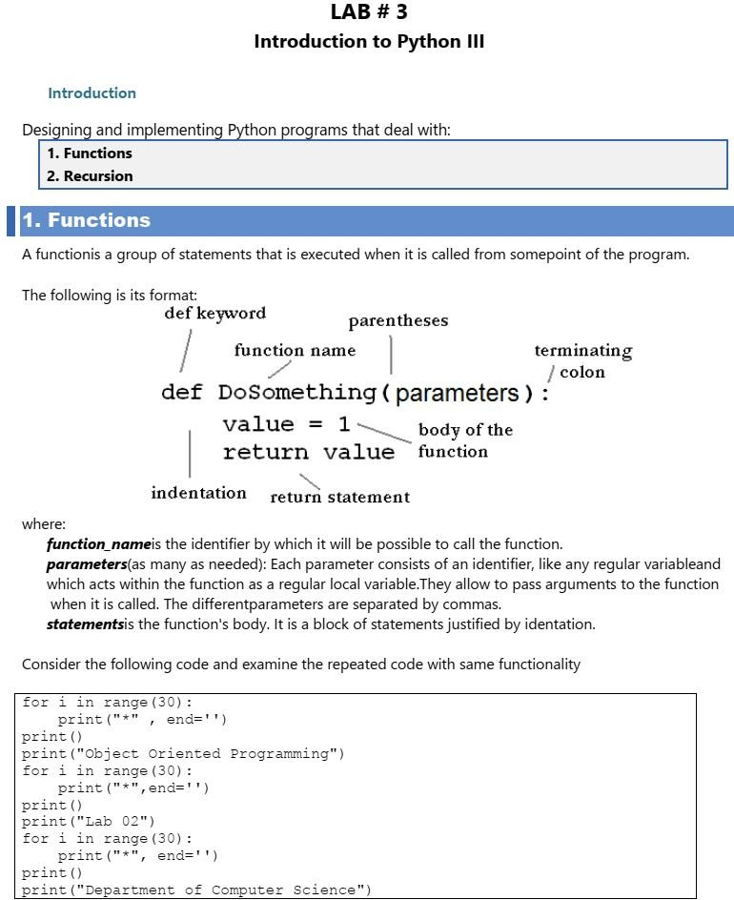

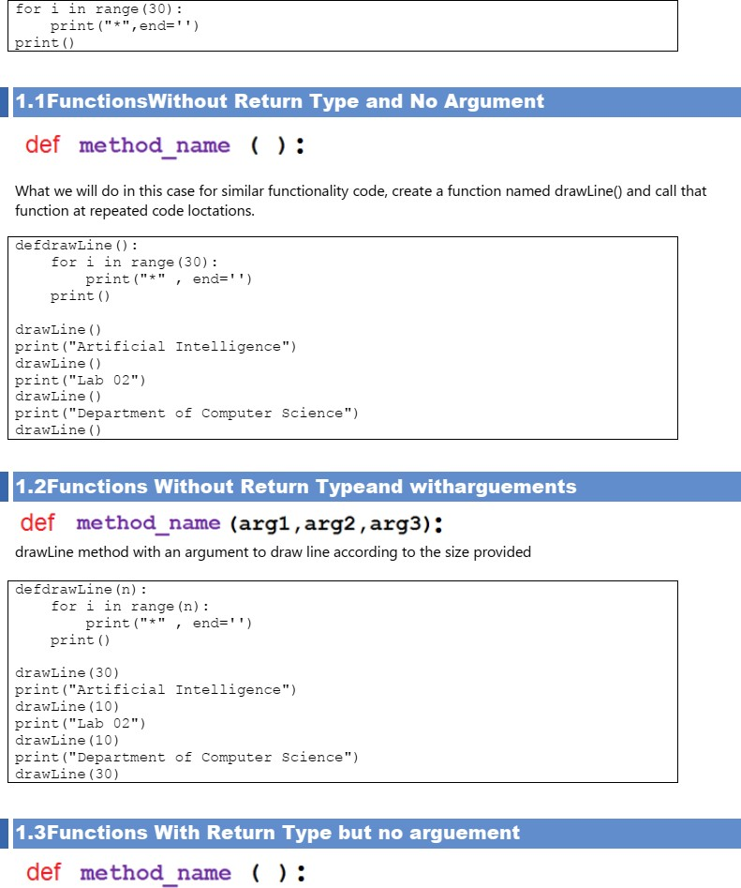

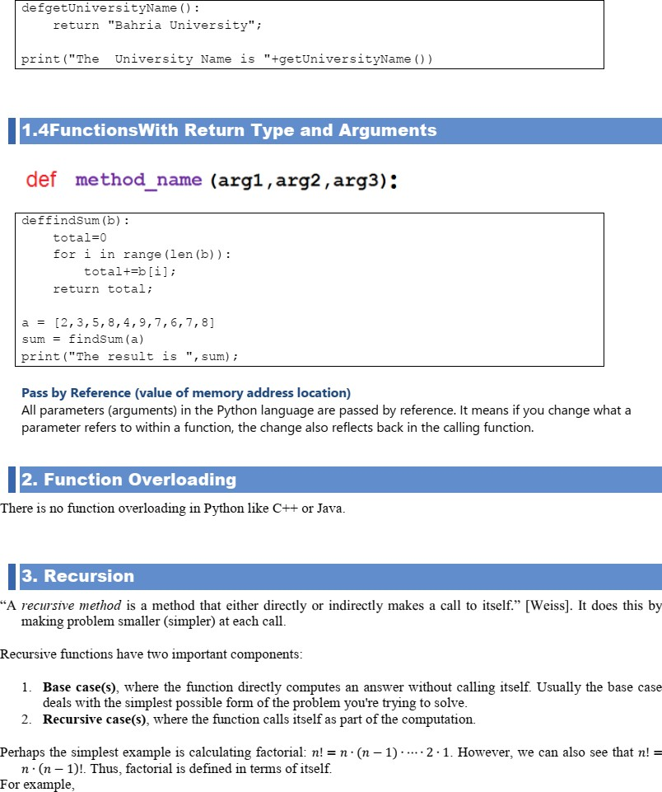

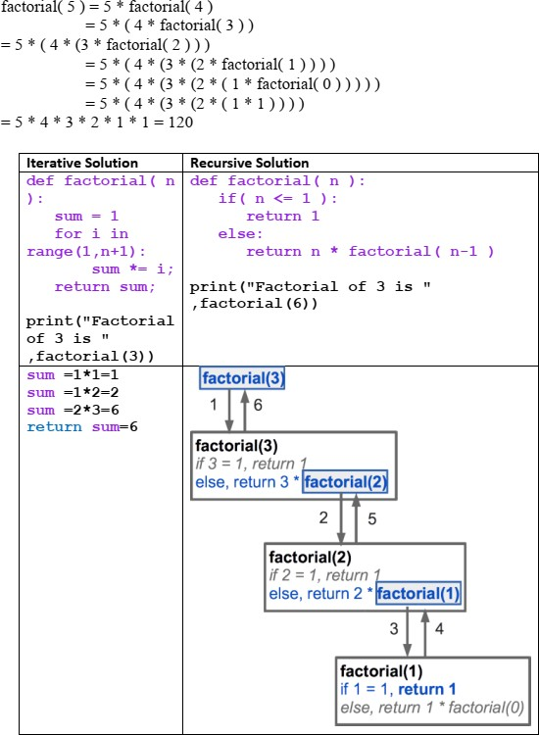

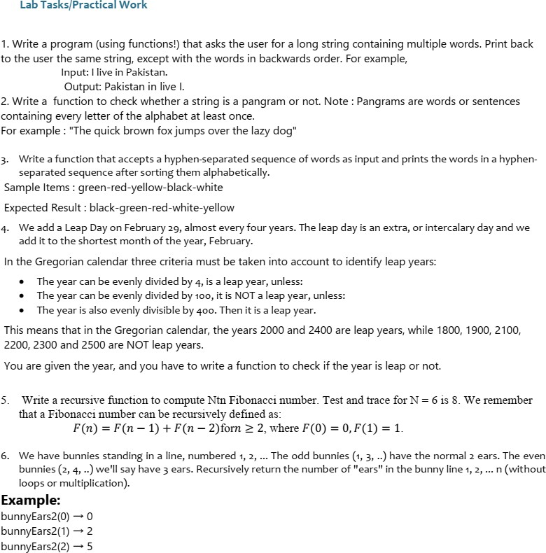

**1. Reverse words in a string**

**Problem:**

Write a function that asks the user for a string with multiple words, then returns the string with the words in reverse order.

#### Code:

def reverse_words():  
 sentence = input("Enter a sentence: ")  
 words = sentence.split() # Split the sentence into words  
 reversed_words = words[::-1] # Reverse the list of words  
 reversed_sentence = " ".join(reversed_words) # Join the words back into a sentence  
 print(reversed_sentence)  
  
reverse_words()

#### Output:

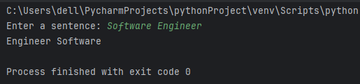

### ****2. Check if a string is a pangram****

#### Problem:

Write a function to check whether a given string is a pangram (contains every letter of the alphabet at least once).

#### Code:

import string  
  
def is_pangram(sentence):  
 alphabet = set(string.ascii_lowercase) # Get all lowercase letters  
 sentence = sentence.lower() # Convert sentence to lowercase  
 sentence_letters = set(sentence) # Create a set of letters from the sentence  
 return alphabet.issubset(sentence_letters) # Check if all alphabet letters are in the sentence  
  
# Example usage:  
sentence = "The quick brown fox jumps over the lazy dog"  
print(is_pangram(sentence)) # Should print True

#### Output:

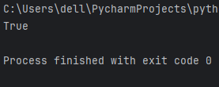

### ****3. Sort hyphen-separated words****

#### Problem:

Write a function that accepts a hyphen-separated sequence of words and prints the words in alphabetical order.

#### Code:

def sort_hyphenated_words():  
 hyphenated_string = input("Enter a hyphen-separated sequence of words: ")  
 words = hyphenated_string.split('-') # Split the string into words  
 sorted_words = sorted(words) # Sort the words alphabetically  
 sorted_hyphenated_string = '-'.join(sorted_words) # Join them back with hyphens  
 print(sorted_hyphenated_string)  
  
sort_hyphenated_words()

#### Output:

#### 

### ****4. Check if a year is a leap year****

#### Problem:

Write a function to check if a year is a leap year based on the Gregorian calendar rules.

#### Code:

def is_leap_year(year):  
 if (year % 4 == 0 and year % 100 != 0) or (year % 400 == 0):  
 return True  
 else:  
 return False  
  
# Example usage:  
year = int(input("Enter a year: "))  
print(is_leap_year(year)) # Will return True or False

#### Output:

#### 

### ****5. Recursive Fibonacci****

#### Problem:

Write a recursive function to compute the Nth Fibonacci number.

#### Code:

def fibonacci(n):  
 if n == 0:  
 return 0  
 elif n == 1:  
 return 1  
 else:  
 return fibonacci(n - 1) + fibonacci(n - 2)  
  
# Example usage:  
n = 6  
print(f"Fibonacci number at position {n} is {fibonacci(n)}")

#### Output:

#### 

### ****6. Recursive bunny ears****

#### Problem:

You have a line of bunnies. Odd-numbered bunnies have 2 ears, and even-numbered bunnies have 3 ears. Write a recursive function to return the total number of ears in the bunny line.

#### Code:

def bunny_ears(n):  
 if n == 0:  
 return 0  
 elif n % 2 == 1: # Odd bunnies have 2 ears  
 return 2 + bunny_ears(n - 1)  
 else: # Even bunnies have 3 ears  
 return 3 + bunny_ears(n - 1)  
  
# Example usage:  
print(bunny_ears(2)) # Should print 5

#### Output:

